Prepared for FPOM 7 August 2019

**Shad Removal Strategies for Columbia and Snake Rivers**

Over the last 20 years, numbers of American shad *Alosa sapidissima* returning to the Columbia River have ranged widely, from 0.9 million in 2011 to the current record of 7.4 million so far this year (Figure 1). Based on 10-year averages, the adult shad spawning run has the greatest overlap with summer Chinook and sockeye salmon (Figure 2). Any potential actions to remove or decrease the numbers of shad in the system will require consideration on how they might impact Chinook and sockeye salmon passage.

Figure 1. Numbers of American shad counted at Bonneville Dam 1994-2019.

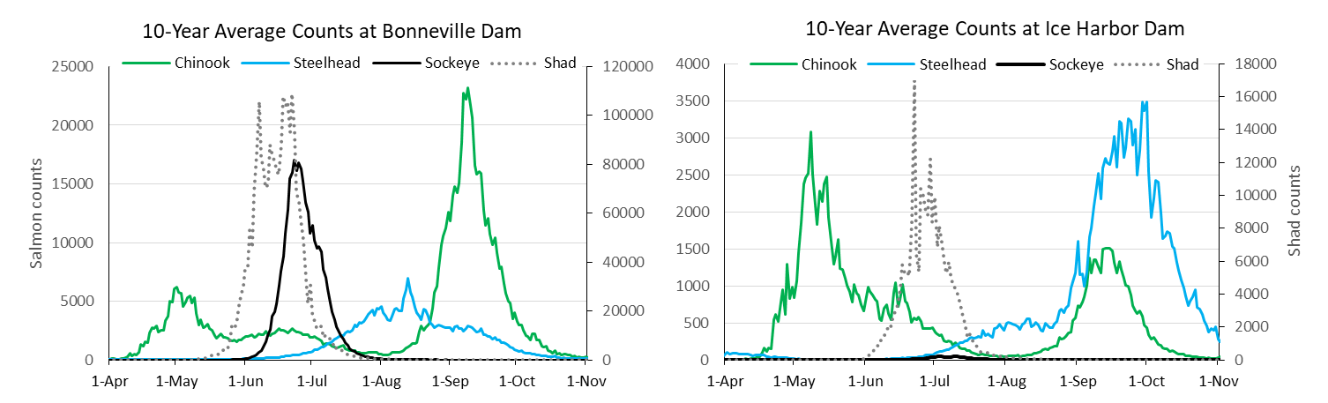

Figure 2. Ten year average counts for American shad, steelhead and Chinook and sockeye salmon at Bonneville and Ice Harbor dams.

Shad are non-native anadromous species and, studies from their home range, indicate they predominately home to natal spawning streams. Analysis of otolith micro-chemistry of adult shad in the York River, PA, indicated that 94% originated from the drainage, 6% were strays from outside drainages (Walther 2007[1]). This suggests blocking access to spawning areas could reduce, but not necessarily eliminate, numbers of adult spawners returning to those areas in the future.

Given the choice to use surface routes or submerged orifices to ascend fishways, American shad exclusively used surface routes in one study (Haro and Kynard 1997[2]). In addition, the authors noted;

“Turbulence, air entrainment, and upwelling flow within the area downstream of the surface weir all appeared to confound appropriate orientation and upstream movement of American shad. American shad generally occupied areas in pools where water velocity and turbulence were minimal, and they appeared to select lower water velocities when ascending the surface weir (i.e., searching and approaching from beneath the high velocity surface flow).”

Options

1. Block or discourage from passage at dams using non-overflow weirs or other design features.

Intent if this option is to use downstream dams to block or discourage shad from reaching upstream areas. A series of weirs with submerged orifice flow only would likely block a significant portion of the adult shad migrants. Use of design features that create adverse condition such as turbulence and higher surface velocities could also be used to discourage passage at a dam, reducing the number that convert to upstream projects.

Pros: Quick response during first year of implementation. Since shad appear to exhibit homing behavior in their native range, the number of upstream migrants may be significantly reduced within a few generations of implantation. However, homing behavior for Columbia River shad has not been investigated.

Cons: Blocking significant numbers of shad within a fishway could potentially (likely?) interfere with salmonid passage. Operational and structural changes to interfere with shad passage could also affect salmonid passage.

1. Remove/harvest shad from fishways.

This option could be implemented along with, or separately from, Option 1. The intent is to minimized numbers of shad in the system through systematically trapping and removing them from one or more projects using the bottlenecks created at fishways.

Pros: Same as Option 1 plus reducing potential interference with salmonid passage from large numbers of shad being held up in a fishway. Free cat food.

Cons: Equipment and operations to collect shad could interfere with passage and cause by-catch of salmonids.

1. Harvest in the ocean prior to adult spawning migration.
2. Selective harvest adult shad in river downstream of Snake River.
3. Use operation changes to discourage spawning in reservoirs.
4. Collection/removal of juvenile shad at bypass systems.

1. Walther, B. 2007. Migratory patterns of American shad revealed by natural geochemical tags in otoliths. Massachusetts Institute of Technology and Woods Hole Oceanographic Institution. Doctoral Dissertation.
2. Haro, A., and B. Kynard. 1997. Video evaluation of passage efficiency of American shad and sea lamprey in a modified Ice Harbor Fishway. NAJFM 17:981-987.